Vitruvian value of π and Geometry of Sacred Cut

Dmitri Kozlov
Research Institute of Theory and History of Architecture and Town-planning
Russian Academy of Architecture and Building Sciences
21-a 7th Parkovaya St. Moscow, 105264, Russia
E-Mail: kozlov.dmitri@gmail.com

Abstract

Keywords: Ancient geometry, Vitruvius, Sacred cut, history of math, pi number
Introduction
In the book X chapter IX of his De Architectura Libri Decem Vitruvius states that if diameter of a wheel is equal to 4 feet the length of its circumference equals to 12.5 feet. Among many approximations of the transcendental number π the fraction 25/8 = 3.125 is known as “Vitruvian” π. The same value of π was used by ancient Babylonians [1] and lately by Albrecht Dürer. In fact it may be a part of an ancient traditional system of speculative geometry. Remains of this tradition survived the World of Antiquity and existed in Europe until the late Middle Ages especially in the field of architecture and building. A reconstruction of the system of ancient speculative geometry was undertook about 50 years ago by Danish engineer Tons Brunes [2]. In this paper I attempted to explain the origin of the “Vitruvian” π on the basis of ideas by Brunes.
The Research
In the Brunes’ reconstruction of ancient geometry a key role belongs to the square with an eight-pointed star inscribed in it. The star is composed of eight straight lines connecting the vertices of the square with the middle points of its sides. The important property of the Brunes star is that its lines generate 3,4,5 right triangles known in ancient times also as “Egyptian” or “sacred” triangles (fig. 1, a).
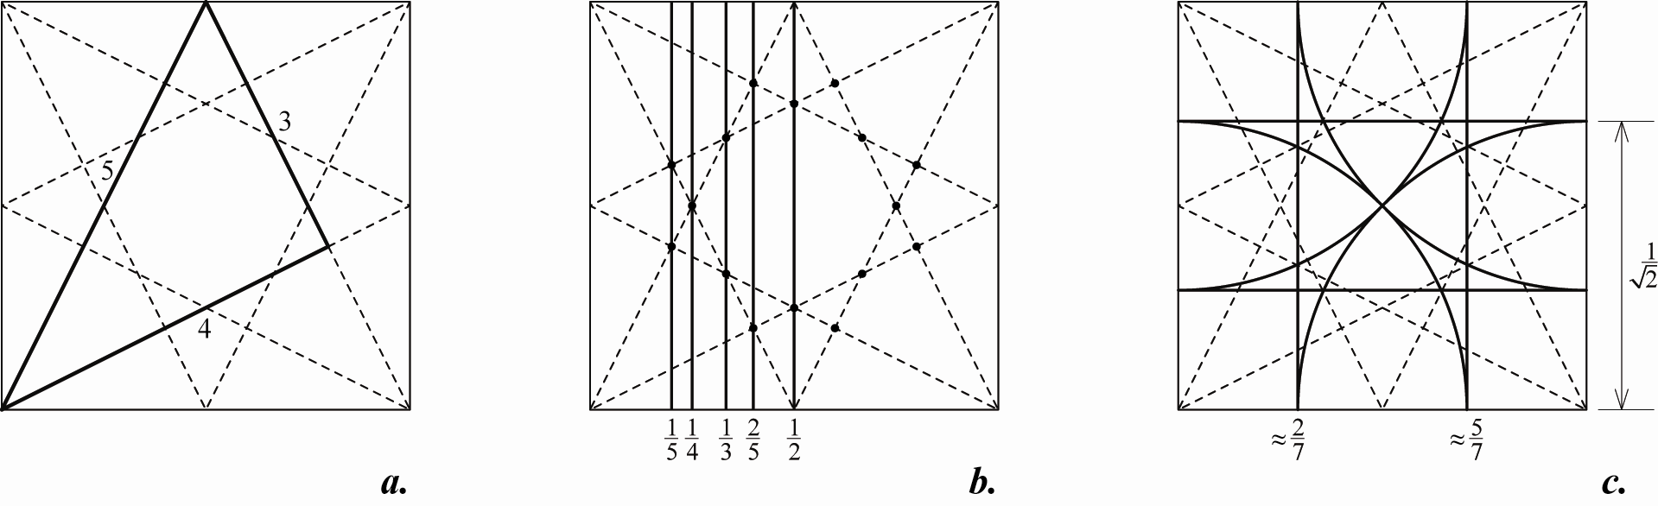
Figure 1

Brunes demonstrated that points of intersection of the star lines can be used to divide the sides of the square into 2, 3, 4 and 5 equal parts and the square can be transformed into regular grids (fig. 1, b). To get the 7×7 grid Brunes used the fact that half the diagonal of the unit square, 0.7071..., approximates 5/7 of its side. Four arcs centered in the vertices of the square and with the radii of 1/2 of the square diagonal construct what Brunes named a “sacred cut” (fig. 1, c). In the sacred cut the division of the side of square into 7 approximately equal parts is combined with rectifying the circle circumference, because the length of each diagonal of half the square that constitutes the eight-pointed star is approximately equal to the length of arc with radius of 1/2 of the square diagonal. The value of π in this case is irrational number √10, that was used as an approximation of π in ancient India [3] and China [4].
Brunes starts from a 10×10 square grid with a circle inscribed in its perimeter. In this case the next 8×8 square perimeter gives a rough approximation of this circle length with the value of π equals to 16/5 = 3.2. This method of circle rectifying was well known in ancient times because it was based on 3,4,5 right triangle (fig. 2, a). The next logical step might contain a comparison of the circle inscribed in the 8×8 square and the 6×6 square namely the next pair of circle and square in the 10×10 grid (fig. 2, b) and the value of π was equal exactly to 3. These two drawings might constitute a starting point in geometrical speculations of the Ancients about the value of number π. To construct Vitruvian relationship between circle circumference and perimeter of square the side of the 6×6 square should be slightly enlarged to the size of 6.4 (fig. 2, c).
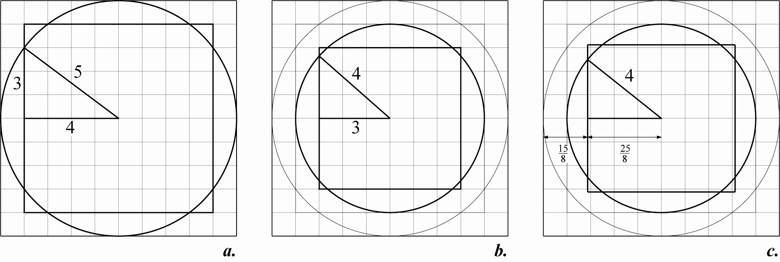
Figure 2

I believe that this idea of enlargement of the square 6×6 to the square 6.4×6.4 was derived from practical construction of the square with the side equal to the side of the Brunes star (fig. 3, a). To do this the sides of the square the star is inscribed in should be divided into four equal parts by using the corresponding points of the star. Eight new points on perimeter of this square are the points that lay on the circle which diameter equals to the side of the Brunes star (fig. 3, b). To construct the Brunes rectification of the circle with π = √10 a square should be circumscribed about this circle and a circle should be circumscribed about the initial square (fig. 3, c).
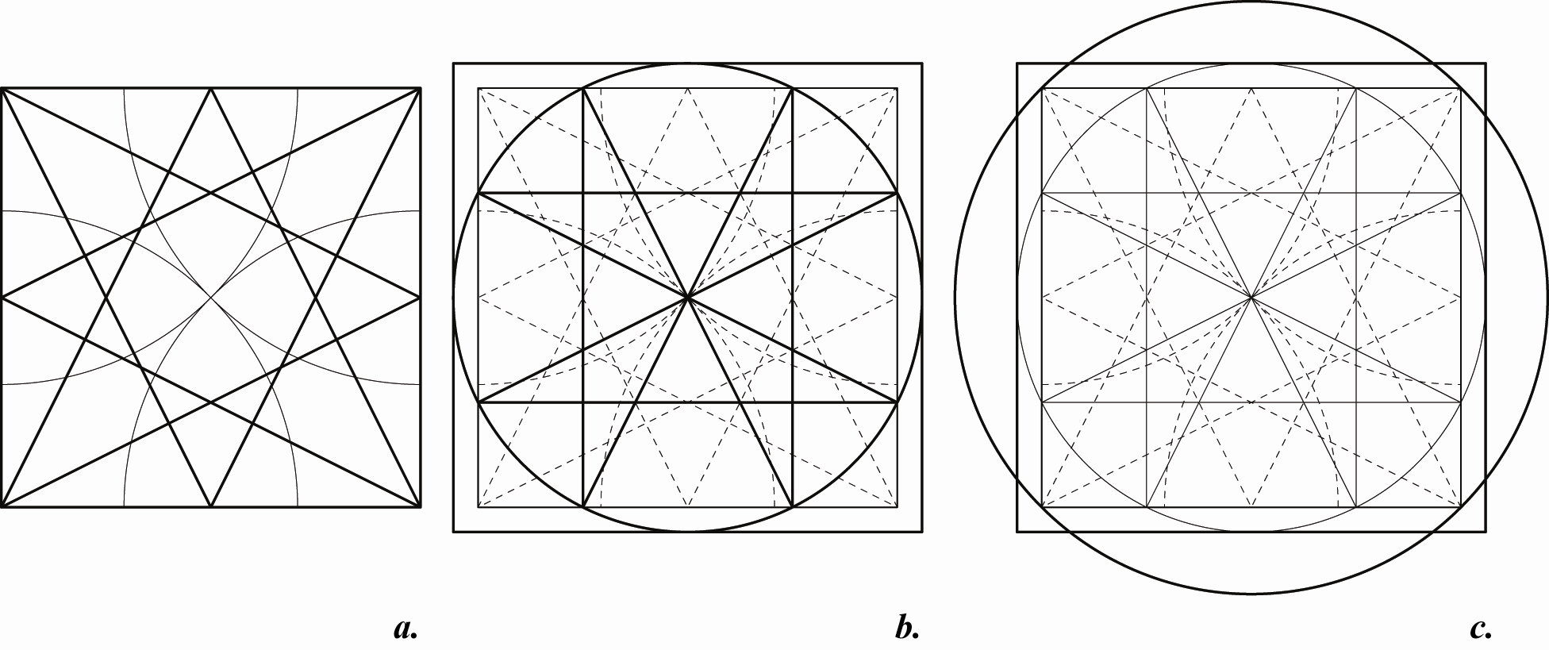
Figure 3

Another idea that is not explicitly given in the Brunes reconstruction but may be logically obtained from it includes doubling of square or ad quadratum construction together with doubling of the Brunes star inscribed in it (fig. 4, a). Recently I had demonstrated that two Brunes stars inscriber in the ad quadratum give points of intersections that make it possible to divide sides of the inner square into seven precisely equal parts [5].
Perimeter of the square inscribed in the circle which in turn is inscribed in the 10×10 square and the length of a circle that crosses the concentric square 8×8 at the points of division half of its sides in two give rectification of the circle with π = √10 (fig. 4, b). These points are also the intersections of the four minor Brunes stars inscribed into each of four quarters of the initial 10×10 square.
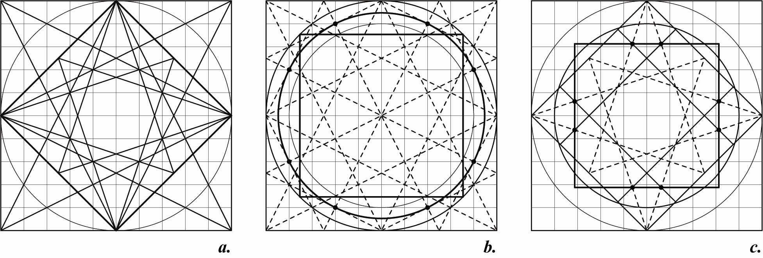
Figure 4

To get rectification of the circle with π = 25/8 the Brunes star should be inscribed in the same square that inscribed in the circle with diameter of 10 but rotated on 45 degrees. If the sides of this square are divided into four equal parts the lines of 4×4 grid intersect the lines of the star at eight points which determinate the sides of the sought-for 6.4×6.4 square (fig. 4, c).
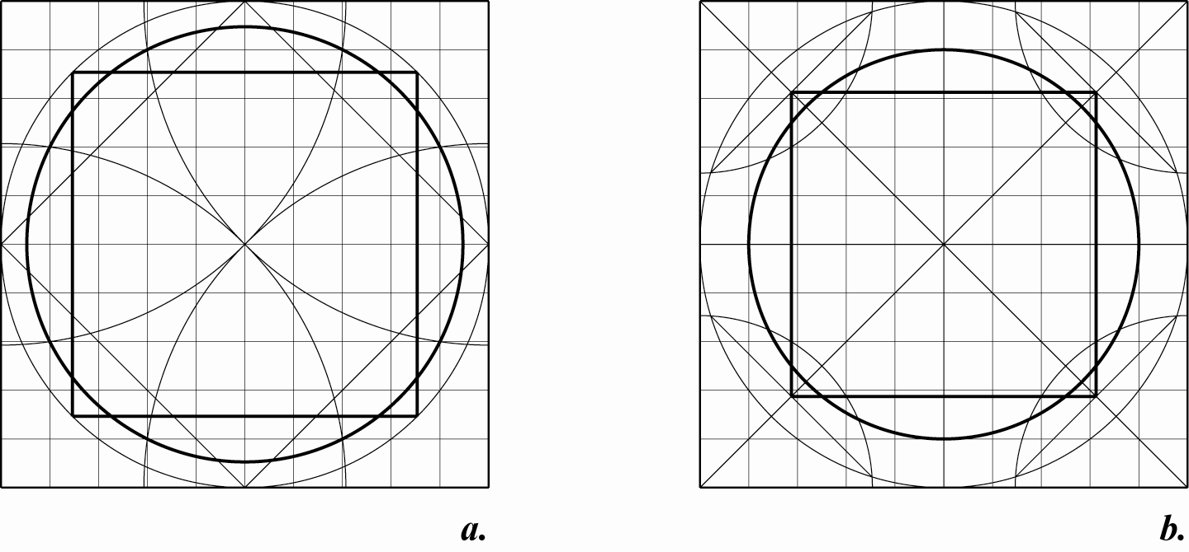
Figure 5

Exactly the same results for the circles and squares may be constructed with arcs of the sacred cut. To construct the circle of the Brunes rectification (π = √10) for the inner square of ad quadratum inside of the basic 10×10 square it is necessary to find eight points at which four arcs of the sacred cut intersect the 8×8 square (fig. 5, a). The points divide half of its sides in two and coincide with the eight points of fig. 4, b.
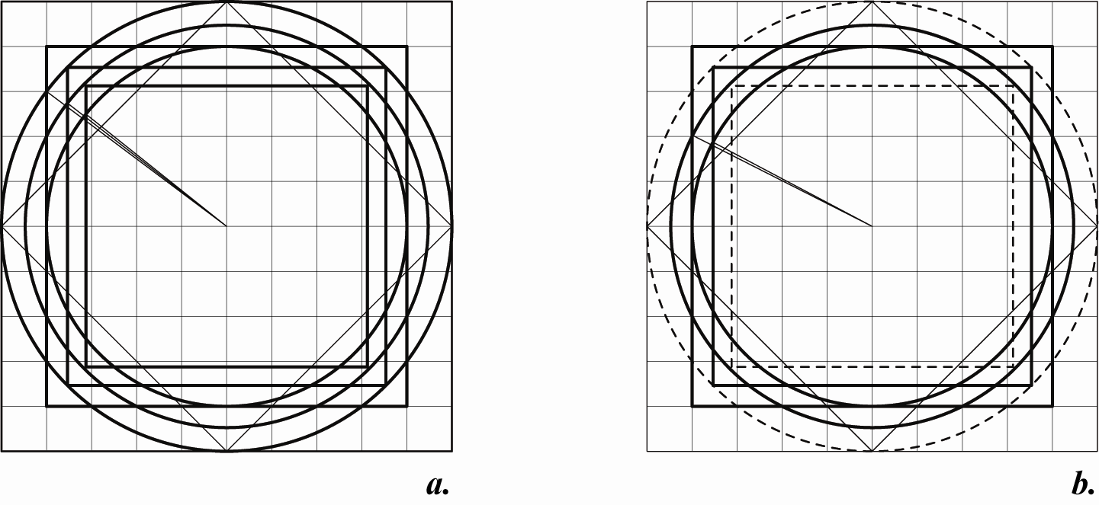
Figure 6

A 6.4×6.4 square may be constructed with sacred cuts applied to four quarters of the 10×10 square. Radical axis of four corner arcs of the sacred cuts of 5×5 squares and the initial circle with diameter of 10 intersect the diagonals of the 10×10 square precisely in the vertexes of the 6.4×6.4 square (fig. 5, b).
Successive application of the Brunes stars and/or sacred cuts to the basic square 10×10 results in emerging of an ensemble of three circles and three corresponding squares (fig. 6, a). Each of the three following pairs represents an approximation of number π known by Ancients: 16/5, √10 and 25/8 namely the “Vitruvian” value. The most important feature of these three π values is that they belong to a geometric sequence and √10 is the geometric mean of 16/5 and 25/8.
This ensemble of three circles and three squares also contains a solution of the circle squaring problem with the same approximate values of π. To get it the largest circle and the smallest square of the ensemble must be thrown away. The remained two circles and two squares give two approximate circle squaring: the first with π = 16/5 and the second with π = 25/8 (fig. 6, b).
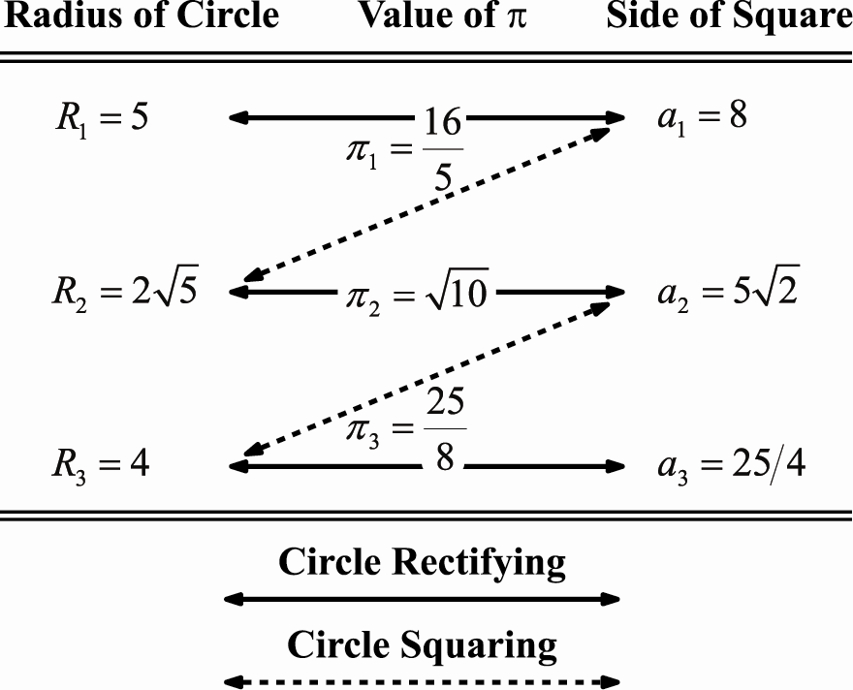
Figure 7

The relationship between the three circles and the three squares, the three approximate values of π, and their application to the problems of circle rectifying and circle squaring are given schematically on fig. 7.
Conclusion
The Brunes reconstruction of ancient geometry can give us an explanation of the origin of the Vitruvian π. Nevertheless it is difficult to agree with Brunes’ hypothesis that this geometry was some sort of “secret” or “esoteric” knowledge kept by temple priests unchangeable through many centuries.
It is much more probable that the most ancient mathematical conceptions were conserved by different professional guilds as part of their own tradition. At the ancient times there was no such a close relationship between science and practice as it is now. Perhaps the ancient geometry in the Brunes reconstruction was a part of traditional doctrine applied to the sphere of architecture and building. I assume that Vitruvius wholly or partly founded his book on this tradition.
References
1. Neugebauer, O. The Exact Sciences in Antiquity, Second Ed., Dover Publication, Inc., New York, 1957.
2. Brunes, T. The Secrets of Ancient Geometry and its Use, Rhodos, Copenhagen, 1967.
3. Struk, D.J. A Concise History of Mathematics, New York, 1987.
4. Scott, J.F. A History of Mathematics, Taylor & Francis Ltd., London, 1958.
5. Kozlov, D. Eight-Pointed Star and Precise Construction of 7×7 Square Grid, Proceedings of Bridges: Mathematics, Music, Art, Architecture, Culture, pp. 331 – 334, 2015.

